**Lab assignment 3**

In our android application, Help! The only sensor used was location, but it was all done in Java with Google maps. In order to integrate Processing with Java we first import the processing-core.jar file into our project.

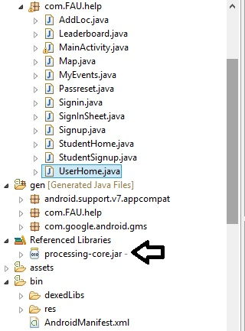

Once the .jar file is imported you can start writing in processing after declaring the proper imports.

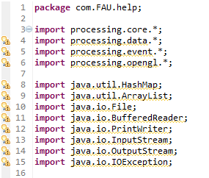

We must extend PApplet to our class so that we can use the functions from processing without issues, such as width.

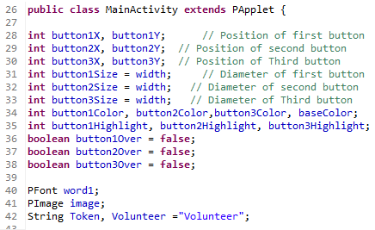

From here on everything is pretty similar to how you would normally write in Processing, such as the drawing of squares rectangles to use as buttons.

